1. What is a repository?

Source Code (based) Repository

Version Controlling

2. What are the different architectures of repositories?

1. Centralized

2. Decentralized

3. Which architecture Git Follows / how is that a better fit compared to the other options

1. Flexibility (Cost, Work)

2. Transactional Workflow

4. Actually doing git hub

5. Doing Git

- Create File

- Add the file to the staging area

- Commit the file

1 sudo yum update

2 clear

3 sudo yum install git -y ----> Git installation

4 clear

5 pwd

6 ls

7 mkdir mylocalrepo ----> Creating a local repo folder

8 ls

9 cd mylocalrepo/

10 pwd

11 ls -la

12 clear

13 git init ----> Initializing my local Git Repository

14 ls -la

15 ls

16 cd .git

17 ls -la

18 cd ..

19 clear

20 vi file1.txt ----> Creating a new file

21 ls

22 git status ----> Checking the current git status

23 git add file1.txt ----> Adding the new file to staging area

24 git status

25 git commit ----> Committing the changes (creating a version)

26 cat file1.txt

27 cat > file1.txt ----> Modifying file1

28 cat file1.txt

29 git status

30 git commit -m "hi" ----> Trying to commit without add (FAILURE!!)

31 git add file1.txt

32 git commit -m "Modified file 1"

33 git log ----> Checking the commit history

Class 2:

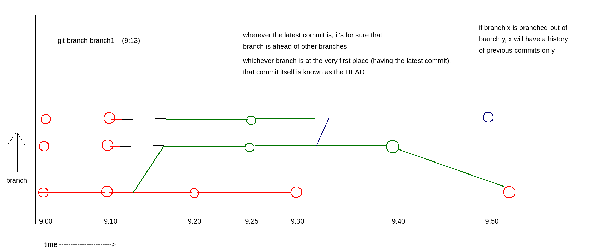

1 sudo yum update -y

2 sudo yum install git -y

3 clear

4 git -v

5 git --v

6 git --version

7 clear

8 mkdir localRepo

9 cd localRepo/

10 git init

11 ls -la

12 clea

13 clear

14 git status

15 git log

16 clear

17 cat >> file1.txt

18 cat file1.txt

19 git add file1.txt

20 git status

21 git commit -m "initial commit, file1 added"

22 git remote add origin https://github.com/sonasonaram/8am_repo.git

23 git push

24 git branch

25 git push -u origin master

26 clear

27 cat >> file2.txt

28 cat >> file3.txt

29 git status

30 vi file1.txt

31 git status

32 clear

33 pwd

34 git add .

35 git status

36 git commit -m "file1 mod, file2_3 added"

37 git push

38 git log

39 clear

40 git branch

41 git branch branch1

42 git branch

43 git status

44 git log

45 clear

46 vi file3.txt

47 git commit -a file3.txt -m "editing file3"

48 git commit -a . -m "editing file3"

49 git commit --help

50 git commit -m "editing file3" -a .

51 git commit -a -m "editing file3" .

52 git commit . -m "sdf"

53 git log

54 git checkout branch1

55 git branch

56 git checkout master

57 git checkout branch1

58 git log

59 cat > file_b1

60 git add .

61 git commit -m "file_b1 added"

62 git log

63 git checkout master

64 git log

65 git push

66 ls

67 git checkout branch1

68 ls

69 cat file3.txt

70 git checkout master

71 cat file3.txt

72 git checkout branch1

73 git push

74 git push --set-upstream origin feature1

75 git push --set-upstream origin branch1

Class 3:

1 sudo yum update -y

2 sudo yum install git -y

3 clear

4 mkdir localrepo

5 cd localrepo/

6 git init

7 cat README.md

8 cat > README.md

9 git add .

10 git commit -m "initial commit"

11 git log

12 <NOT THERE BCZ VISHAL DID A MISTAKE>

13 git branch

14 git branch feature1

15 git checkout feature1

16 git checkout master

17 clear

18 ls

19 cat > code1.c

20 git branch feature2

21 git add .

22 git commit code1.c -m "first code added"

23 git branch feature3

24 ls

25 git checkout feature1

26 ls

27 cat >> code2.c

28 git add .

29 git commit - "code 2 development completed"

30 git commit -m "code 2 development completed"

31 ls

32 git checkout master

33 git merge feature1

34 ls

35 git log

36 git checkout feature2

37 ls

38 cat >> code3.c

39 git add .

40 git commit -m "code3 added"

41 git checkout master

42 ls

43 cat >> code4.c

44 git add .

45 git commit -m "code 4 developed"

46 ls

47 git log

48 git merge feature2

49 ls

50 git log

51 cat >> code4.c

52 cat code4.c

53 git add .

54 git commit -m "change in code 4"

55 cat >> code4.c

56 git add .

57 git commit -m "change in code 4 again"

58 ls

59 git branch

60 git checkout -b branch1

61 ls

62 vi code4.c

63 git add .

64 git commit -m "editing code4 on b1"

65 git checkout master

66 git checkout -b branch2

67 ls

68 vi code4.c

69 git add .

70 git commit -m "editing code4 on b2"

71 git checkout master

72 clear

73 git merge branch1

74 git log

75 git branch branch1

76 git checkout branch1

77 git log

78 git checkout branch2

79 git log

80 clear

81 git checkout master

82 git merge branch2

83 cat code4.c

84 git checkout branch2

85 vi code4.c

86 git status

87 git add .

88 git commit -m "solved a conflict on code 4, kept both"

89 git log

90 cat code4.c

91 git checkout -b branch3

92 cat code4.c

93 cd ..

94 rm *\

95 rm *

96 rm -rf *

97 clear

98 mkdir localrepo

99 cd localrepo/

100 git init

101 clear

102 cat > file1

103 git add .

104 git commit -m "file1 on master"

105 cat > file2

106 git add .

107 git commit -m "file2 on master"

108 clear

109 git checkout -b branch1

110 ls

111 cat > file3

112 git add .

113 git commit -m "file 3 on branch 1"

114 cat > file4

115 git add .

116 git commit -m 'file 4 on branch 1"

117 git commit -m "file 4 on branch 1"

118 clear

119 git checkout master

120 cat > file5

121 git add .

122 git commit -m "file 5 on master"

123 ls

124 clear

125 ls

126 git rebase branch1

127 git log

128 clear

129 ls

130 git checkout branch1

131 ls

132 git checkout -b branch1_1

133 ls

134 cat >> file1_1

135 cat >> file1_2

136 git add .

137 git status

138 git restore --staged file1_1

139 git status

140 git commit -m "file1_2"

141 git status

142 git add .

143 git commit -m "file1_1"

144 git log

145 git checkout branch1

146 cat >> file_b1

147 git add .

148 git commit -m "file_b1"

149 git checkout branch1_1

150 cat > file1_3

151 git add .

152 git commit -m "file1_3"

153 git checkout branch1

154 git rebase branch1_1

155 git log

156 clear

157 cd ..

158 rm -rf *

159 mkdir localRepo

160 cd localRepo/

161 git init

162 git pull https://github.com/sonasonaram/repo_morn_8.git

163 ls

164 git log